Mental Health Response Advisory Committee (MHRAC)
Meeting Minutes
August 16, 2022
Via Zoom

Board Members in Attendance
Rachel Biggs Albuquerque Health Care for the Homeless
Max Kauffman Disability Right of New Mexico
Matt Dietzel APD Crisis Intervention Division
Paula Burton NAMI Peer Representative
Emily Jaramillo Albuquerque Fire Department
Coty Maxwell Crisis Intervention Division
Mariela Ruiz-Angel Albuquerque Community Safety
Mary Perez UNM Psychiatry & Behavioral Sciences
David Ley New Mexico Solutions
Gilbert Ramirez CABQ-Dept. of Family & Comm. Services
Betty Whiton NAMI
Robert Salazar NAMI Peer Representative
Nils Rosenbaum APD Behavioral Science Services

Introduction to MHRAC
The Mental Health Response Advisory Committee (MHRAC) was created by the Court Approved Settlement Agreement (CASA). We’ve been around since day one and have a focus on three areas, resources, and resources being available to access different things within the city that APD and first responders can use as it impacts homelessness and mental health issues. We are also involved in training and policy; training is one of those things we made a tremendous impact on. As far as the training that is offered. Policies are one of those things where the MHRAC is involved with assisting in writing and approving and recommending policy as it relates again to the narrow focus; we think narrow, but sometimes it gets pretty wide focused on how law enforcement interacts with those experiencing homelessness and those experiencing a mental health crisis.

Roll Call, Max Kauffman
Thirteen of the Board Members were present (names listed above)

Welcome first-time guests
No First Guest

Approval of meeting minutes
1st Motion – Betty Whiton
2nd Motion – David Ley
Minutes from the July meeting were approved pending the correction of a misspelled word on page nine, the word “stalking” was spelled as “stocking.”

Public Comment (Two minutes per person)
None

Nomination of New Board Members, if any, Rachel/Max
No nominations were made

Albuquerque Community Safety Department update, Mariela Ruiz-Angel
Jasmine and Mariela
- Over the last two weeks, we have moved into a new building over at the Gibson Medical Health Center, also known as the Gibson Hub; we are in the education building
- Total CFS = Calls for Service for July is 1,848; they slowed down for this month and going into August. A lot of our resources have been put towards the downtown areas, specifically for Coronado Park
- Our RMS=Records Management System, we are still in the transition process; it’s a little tricky to get three different departments to come together and get things situated
- Some of our wins that we want to highlight from our core position are from our core responders, which are not necessarily involved in the overall numbers because they are more of a specialty types responder who does focus on a lot of follow-up and case management, not intense case management but more along the science of getting people connected to services
- ACS is an alternative to policing and an alternative to help with 911 calls
- Numbers are low due to engaging in doing outreach which is needed right now, as you know homelessness has increased and we are having to figure out what is going to happen with Coronado Park
- Quality Assurance is important so we have been leaning on some of you actively to guide us and to connect us to resources such as 3rd party mental behavioral health providers for our staff.
- We have been looking and leaning heavily on policies and protocols and assessments for suicide as well as other types of diagnosis. We don't want to diagnose, but we do want to make sure that we are covering a certain level of understanding as we get ready to either transport somebody or get them connected to the right services.
- Training has become a big piece of where we are at. We are preparing our team for the next level of growth. We are also making sure that they are taken care of emotionally, physically, and mentally
- Our information and data are available on the ACS Website
www.cabq.gov/acs/documents/acs-monthly-informational-report-July-2022-condensed

Betty Whiton
Q. Did you get a chance to get QPR training for ACS staff?

Jasmine
A. Yes, we actually have some dates scheduled for September; the instructor is out of the country until September

David Ley
QPR=Question Persuade Refer is one of the leading kind of intervention strategies for suicide prevention and awareness

Briget
To David Ley: Q. You guys use a great tool for suicide assessment; I'm wondering if you could talk a little more about that beyond QPR? QPR is pretty basic for a lot of us who've done this for a while. What you are using with your CSW is a great program; a much better way to decide if someone is right there at that point, or not.

David
I can have our Clinical Director, Tara Scuss, share with you the tool that we use internally. It is a fairly standardized assessment around suicide risk. You absolutely cannot rely on any of these instruments to be a hard cold and fast rule-out of suicidality; things can change quickly. Suicidal behavior and ideation can be contextual.

Mariela
I want to mention that 988 is coming up a lot; I want people to know that we are trying to keep a pulse at a tab on where ACS can plug into 988

Rachel
Q. What is the best way to get ahold of ACS if you want an immediate response?

Mariela
A. For non-emergencies, 311, for emergencies 911 or 242-COPS, depending on the severity, they will help triage to determine where the call gets routed

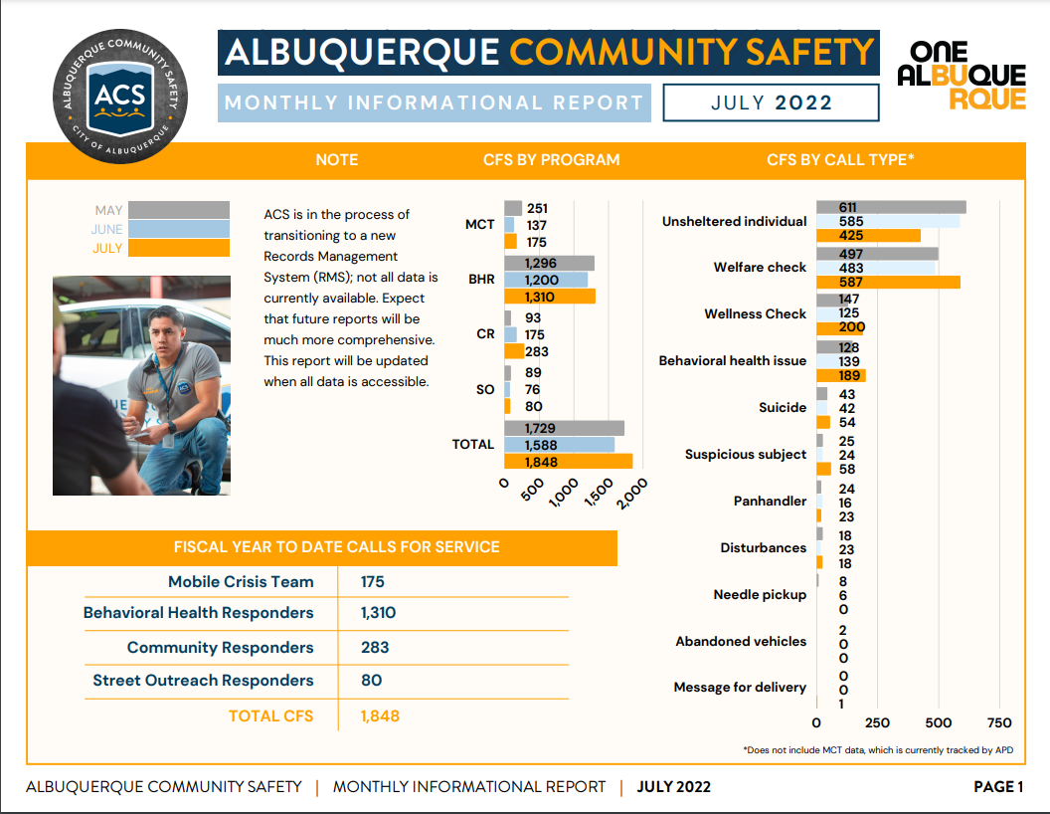

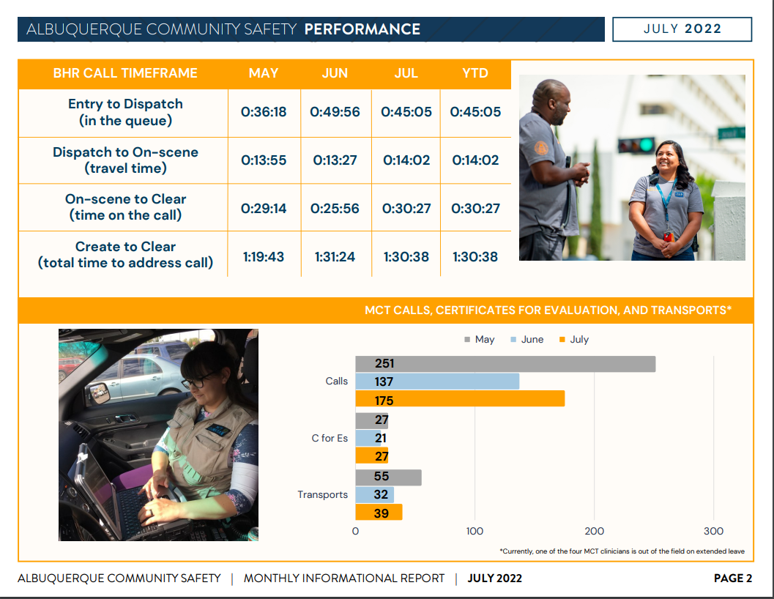
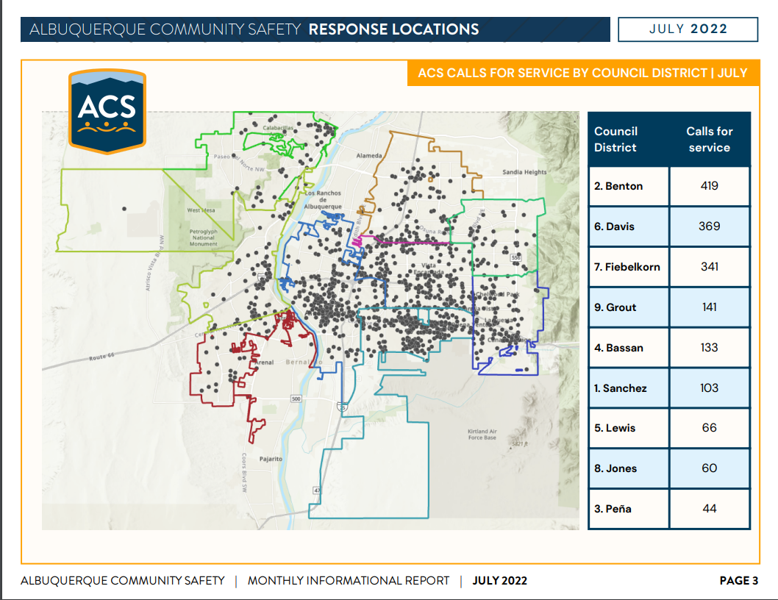

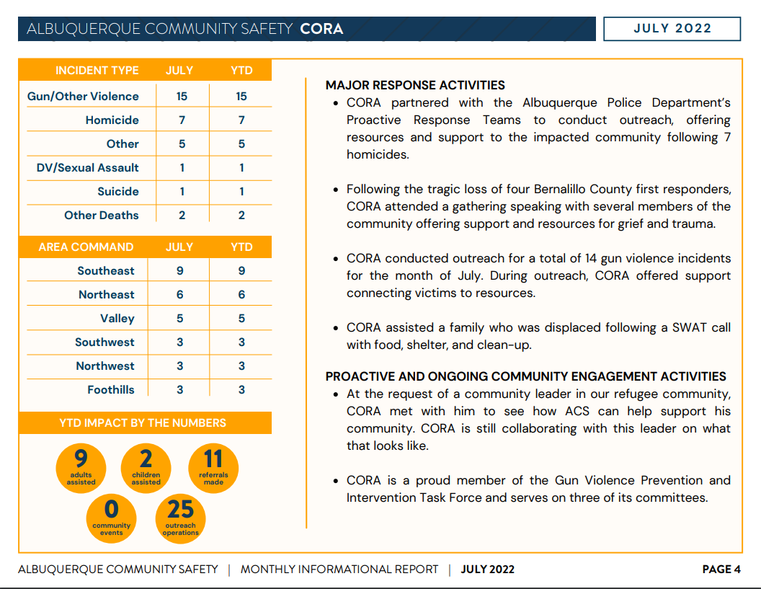

Gibson Health Hub, Family and Community Services, Cristina Parajon

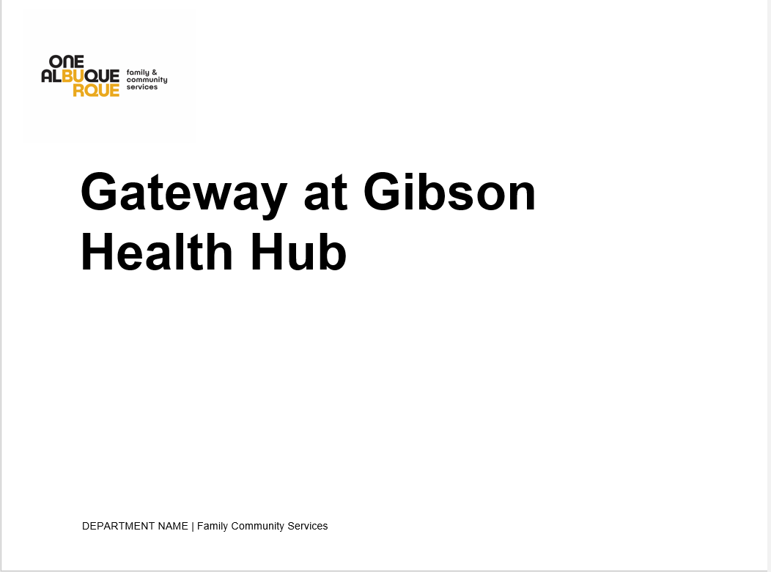

- 30% of our space is being used and the building sits on 20 acres
- Composed of our current tenants, three are accredited hospitals
- 20% is unallocated, so it is available
- 10% is City of Albuquerque offices and that includes ACS
- 40% has been allocated to various projects, including the Gateway Medical Respite and Sobering
- At Gateway we are trying to build more than just beds
- MHRAC is an important player for our first responder drop-off
- The outdoor space we have planned is a dog park, people are allowed to bring their pets into the shelter, it is well lit, and there are some shade areas
- We have completed demolition for the Gateways and we have received construction bids; construction should get started in the next two weeks, or so
- We have selected the service provider who will be operating the Gateway which is Heading Home. They bring a lot of experience to the table with running shelters. They will be providing some services for first responder drop-off (linen changes, maintenance, etc.)
- We have hired three new staff, two community outreach coordinators, and a data analyst
- We are working with UNM Family Residence to conduct a barrier analysis with our providers in the area, specifically, trying to understand why Native American People experiencing homelessness do not access the sheltering system here in Albuquerque.
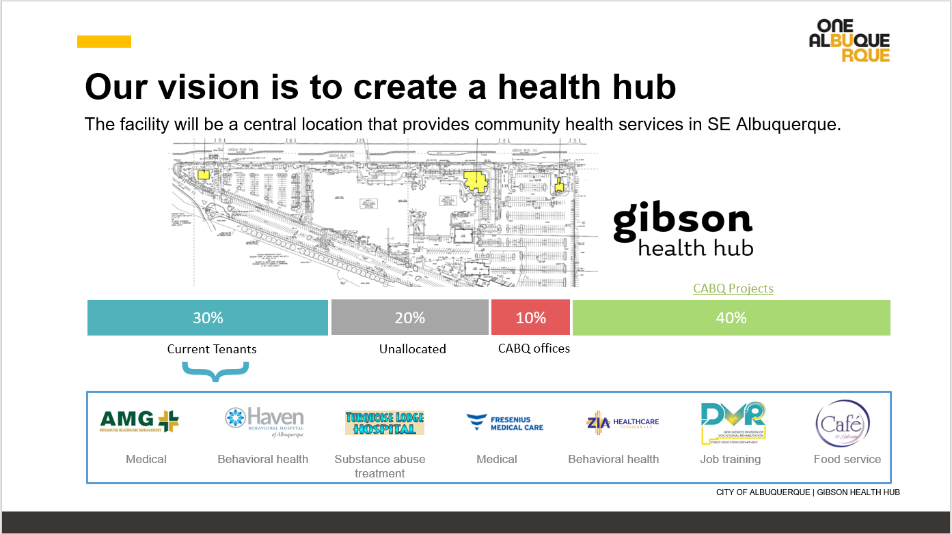

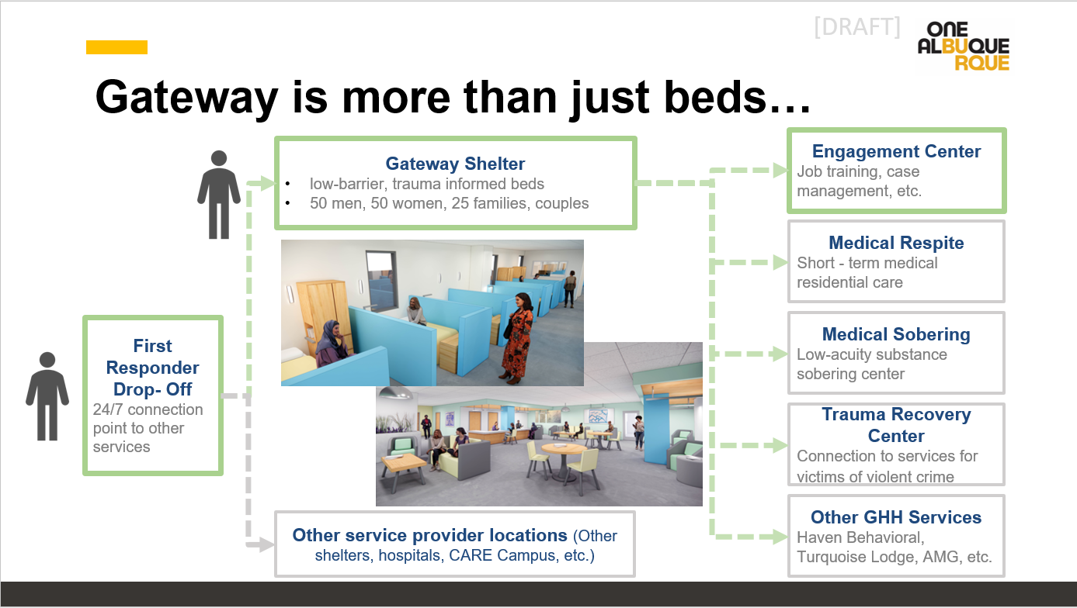

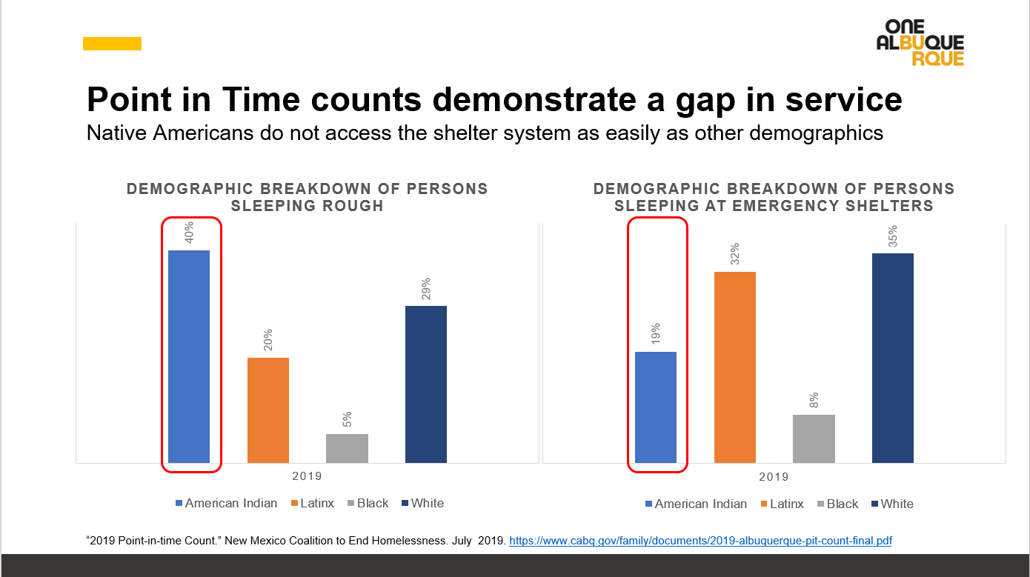

Max
Q. Is it open to men and women now?

Cristina
A. We are still working on the first phase which is 50 single women. The second phase will include men, women, families, and couples. When construction is completed with the Medical Respite and Sobering, which will be open to people of all genders.

Rachel
Q. For phase I, having women, is that still planned for the end of the year to have that open?

Cristina
A. Yes, we are looking towards this winter.

Rachel
Q. When will phase II happen for the men and families?

Cristina
A. We will start programming that this year as well; we will have a clearer estimate on that date in the coming months.

Rachel
Q. Just to be clear, the Medical Respite and the Sobering all start in phase I as well, correct?

Cristina
A. Yes they will start in phase I; they may open a little after the Gateways shelter just because we are prioritizing and want to get that project out.

Coronado Park Plan Update, Carol Pierce, DC Brown, Mariela Ruiz –Angel
Carol Pierce
- There have been health and safety concerns about the people that reside at Coronado Park
- The implementation that you are hearing about is to connect people to services

DC Josh Brown
- Last night we arrested a homicide offender who committed a homicide in Coronado Park in June.
- We have had 418 calls for service just this year for one centralized location, which is a lot of calls for service.
- We have had multiple firearms recovered, 4500 fentanyl pills, 3,008 grams of meth, and… (see slide)
- We are not stigmatizing the homeless as being criminals, and we are not criminalizing the homeless population; it has to do with the preying on people within that population. We have had human trafficking, the selling of narcotics, along with firearms that were recovered on that property, etc.

Mariela Ruiz-Angel
- ACS is heavily involved in helping Coronado Park; we have spent a lot of quality time at Coronado Park
- We informally saw a community; where some people had some sort of safety net.
- We noticed that people living there were scared to report folks who were coming down on them
- Over the last two months, we have gone out and done active outreach to anywhere from 90-150 individuals two to three times a week; that did not include calls for service out there. We would either transport folks to the WEHC or to the hospital for those who needed medical attention. We were able to get some individuals connected back with their providers.
- We were not able to make a huge dent; we had about a 10% success rate after all the times we went out there.
- We’ve prepared businesses for what might be happening about five miles surrounding Coronado Park so they would know they have the support of APD and ACS
- Businesses asked if they could get trained on how to handle these types of situations

Carol Pierce
- The city has had one of the bus stops at Coronado Park; there has been an increase in concern about safety among people that want to get on the bus at that bus stop; those who want to get out to the WEHC but have also been preyed upon
- The Mayor and the city have said we will be closing Coronado Park at the end of August.
- That is part of why we are coming to MHRAC to let you know what we have been doing and this overview.
- We have been doing intensive outreach with partnering organizations
- We are changing the WEHC shuttle bus schedule
- Storage will be available
- We have been completing surveys at Coronado Park to see who is getting or needing what
- Twenty-one people have received vouchers for housing; that came as a result of doing the survey
- We have had the WEHC van there but not everyone is wanting to go out to a shelter
- We had our street medicine folks and a couple of people did receive care

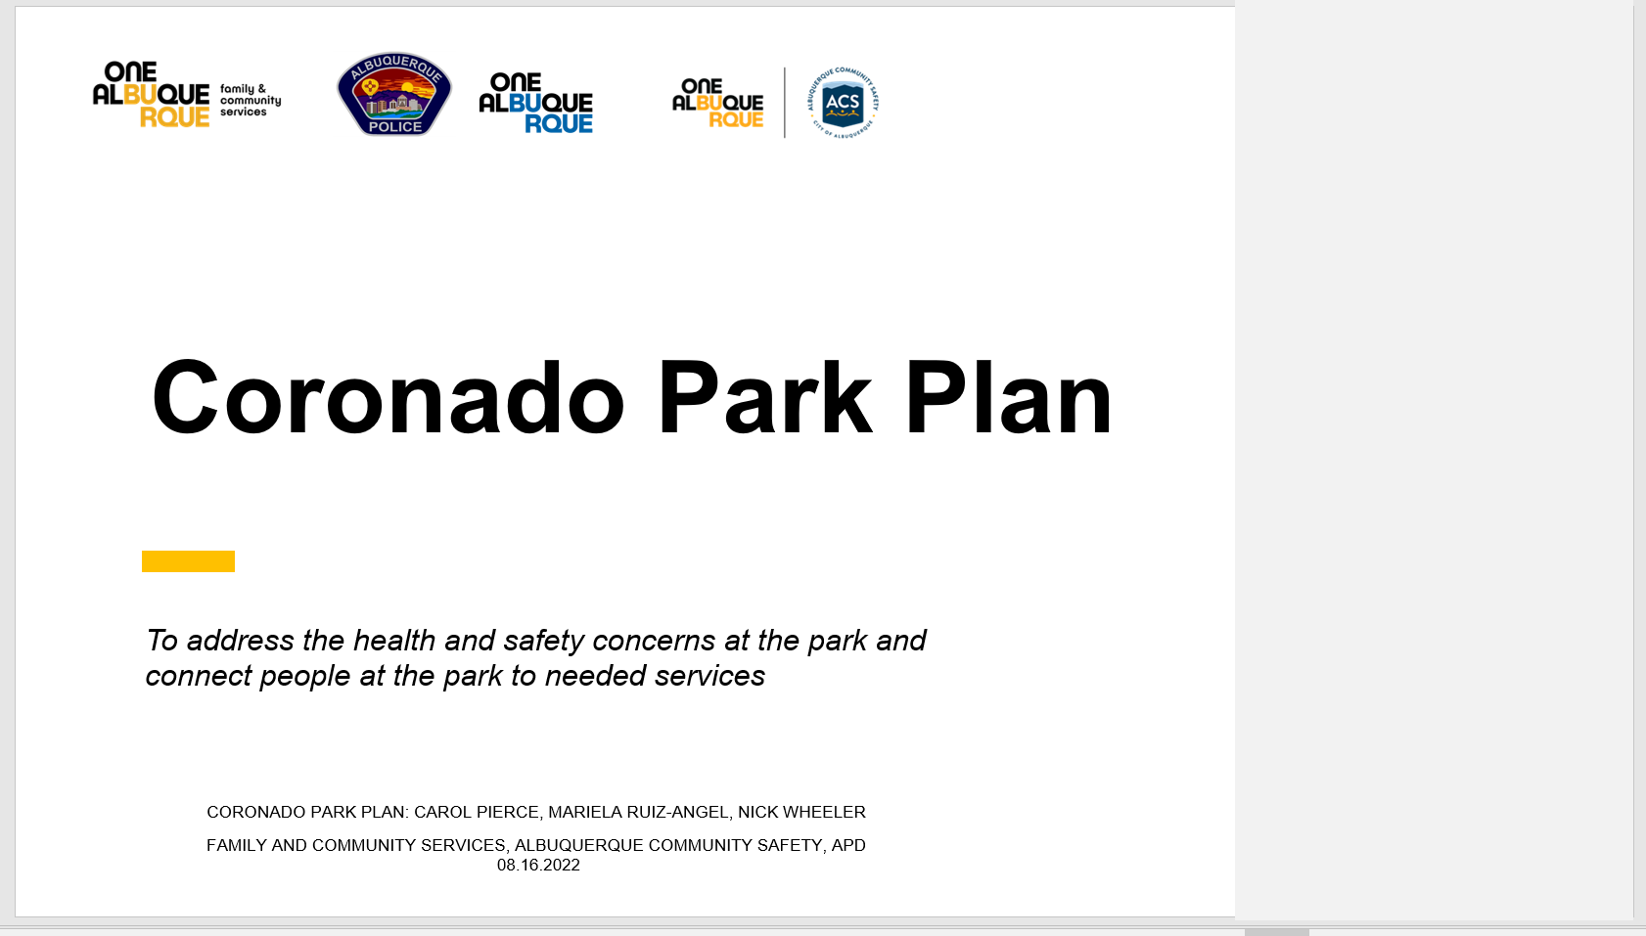
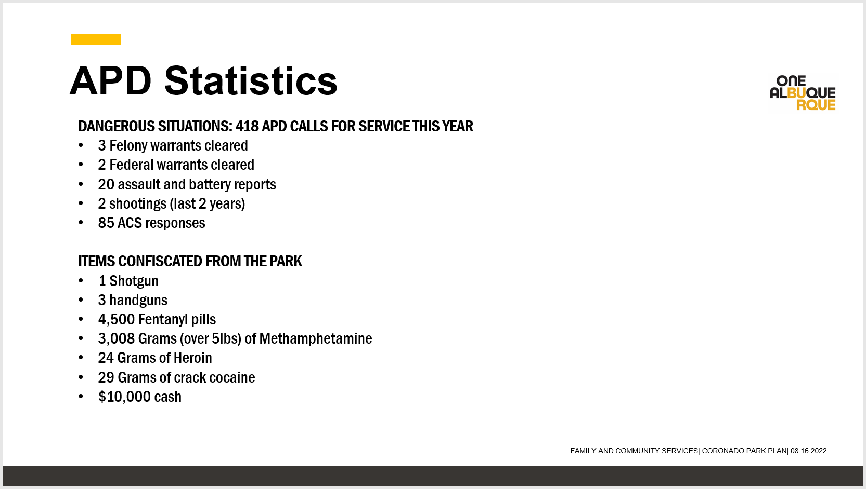

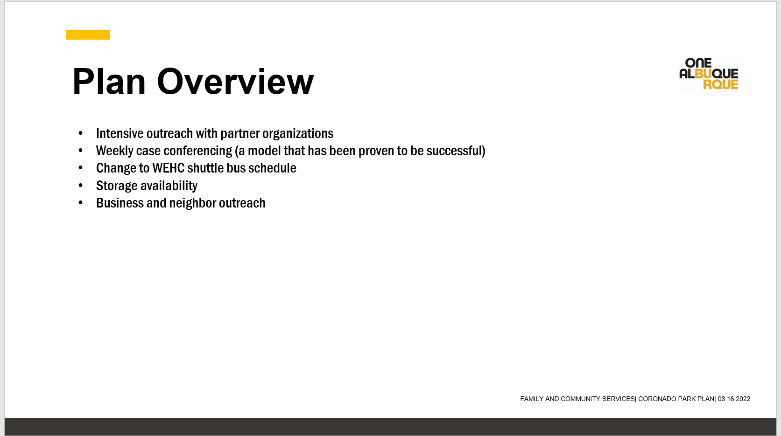
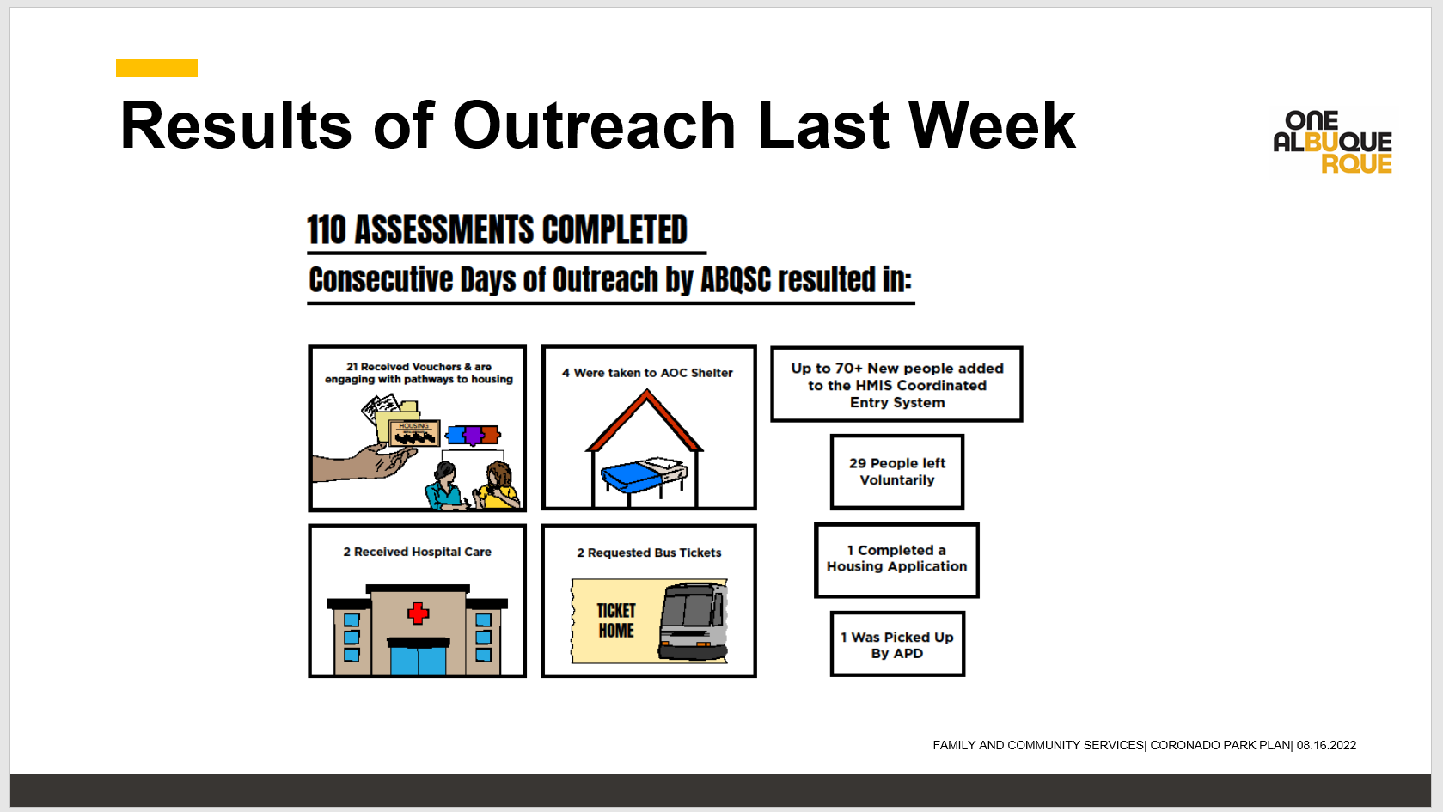

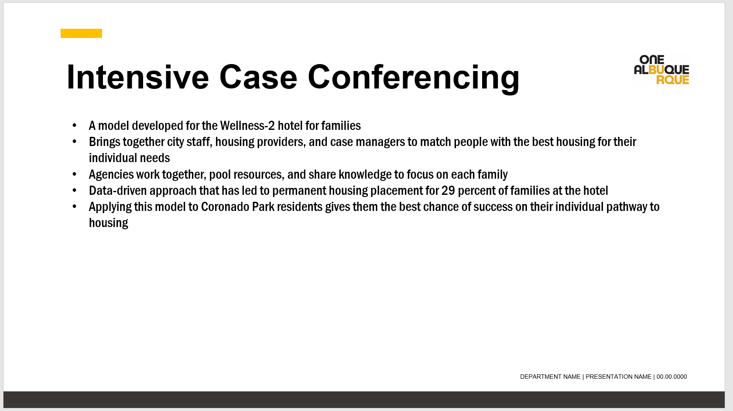
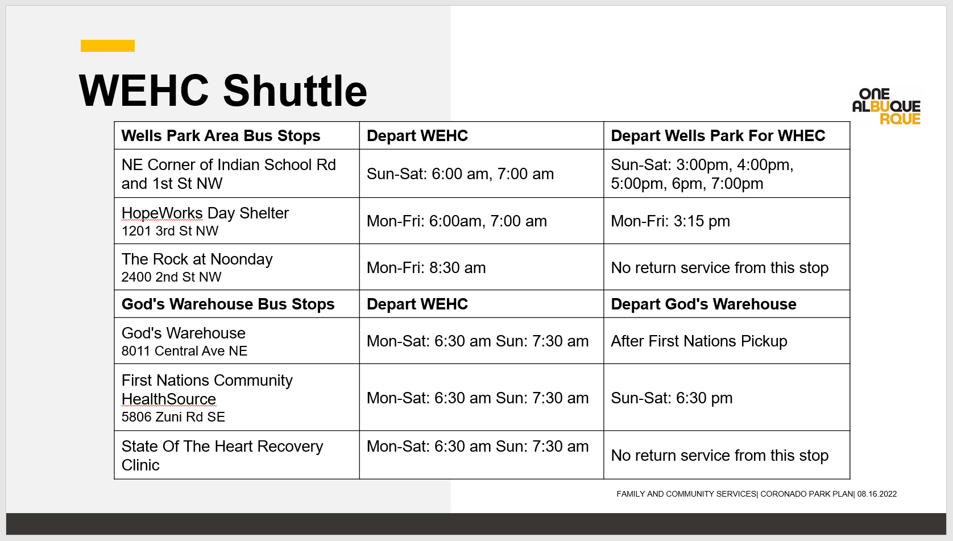

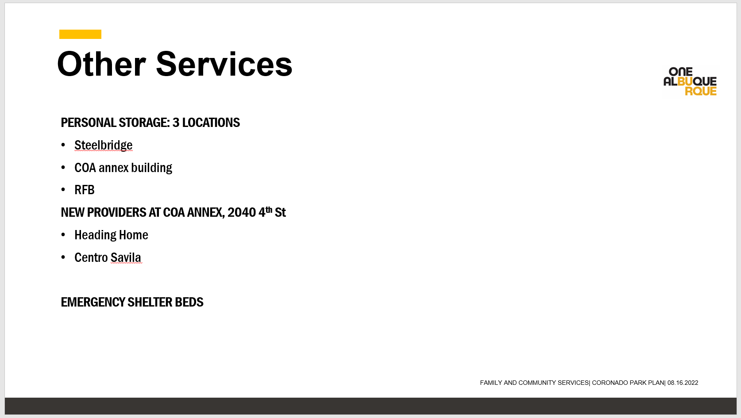
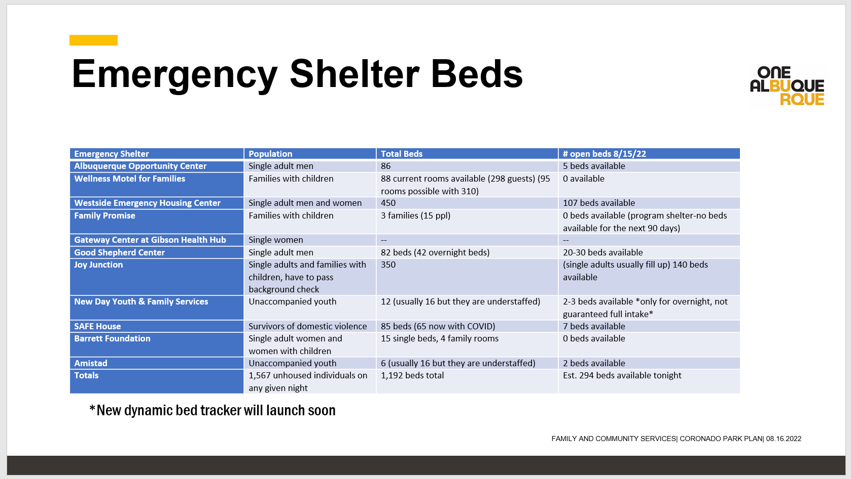

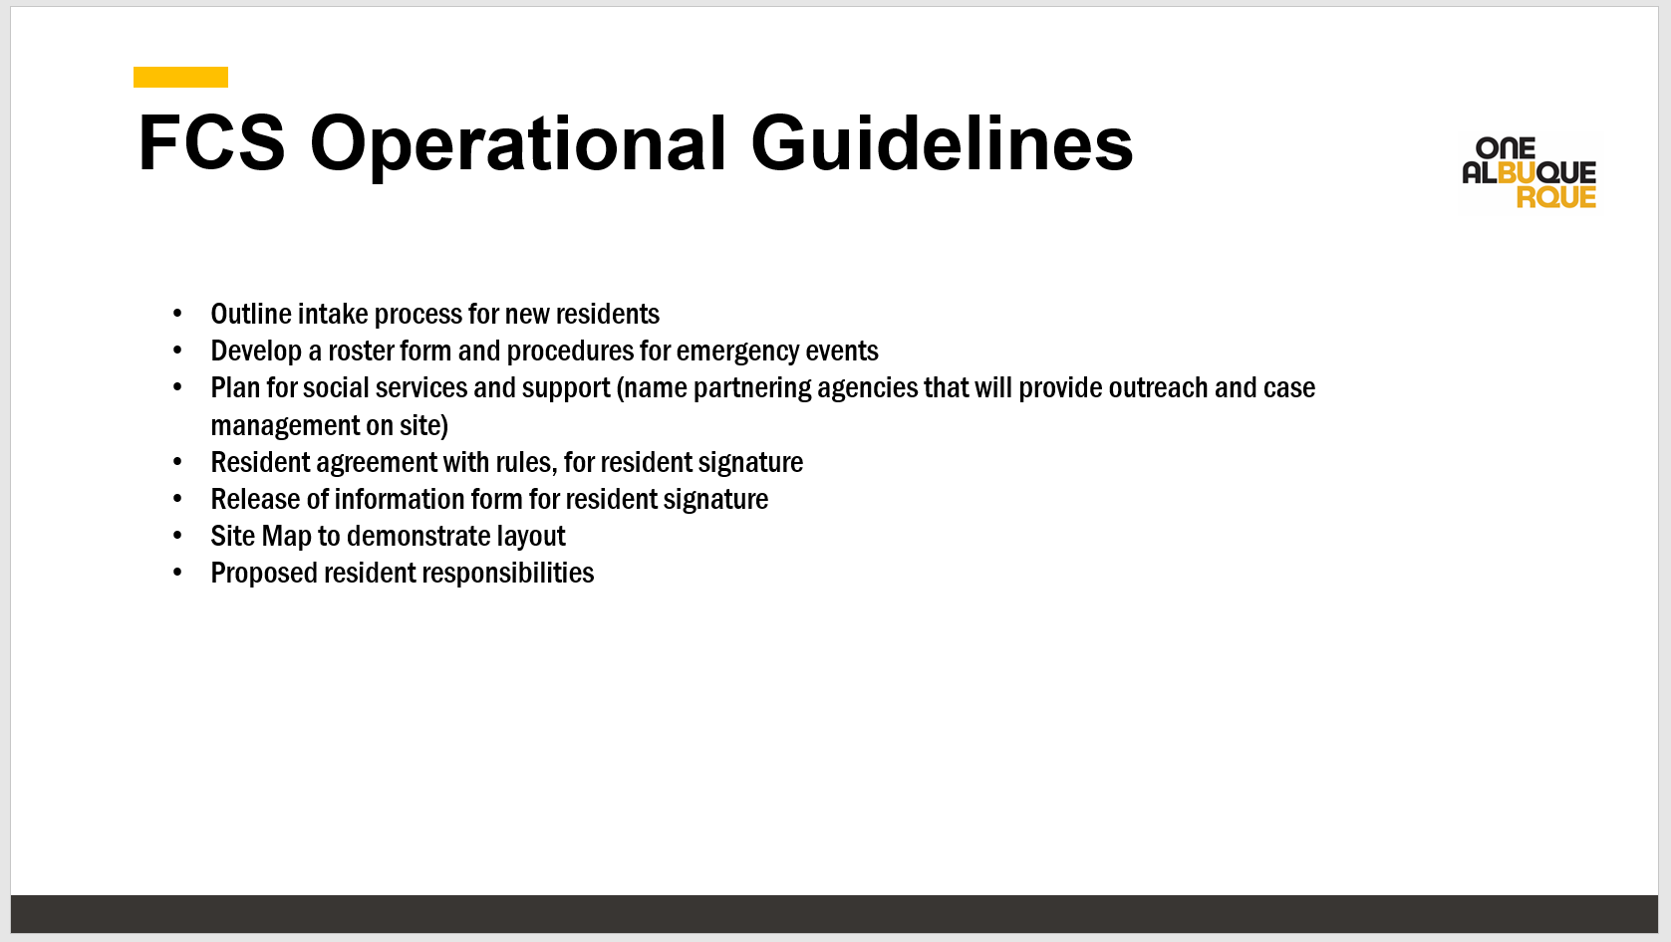

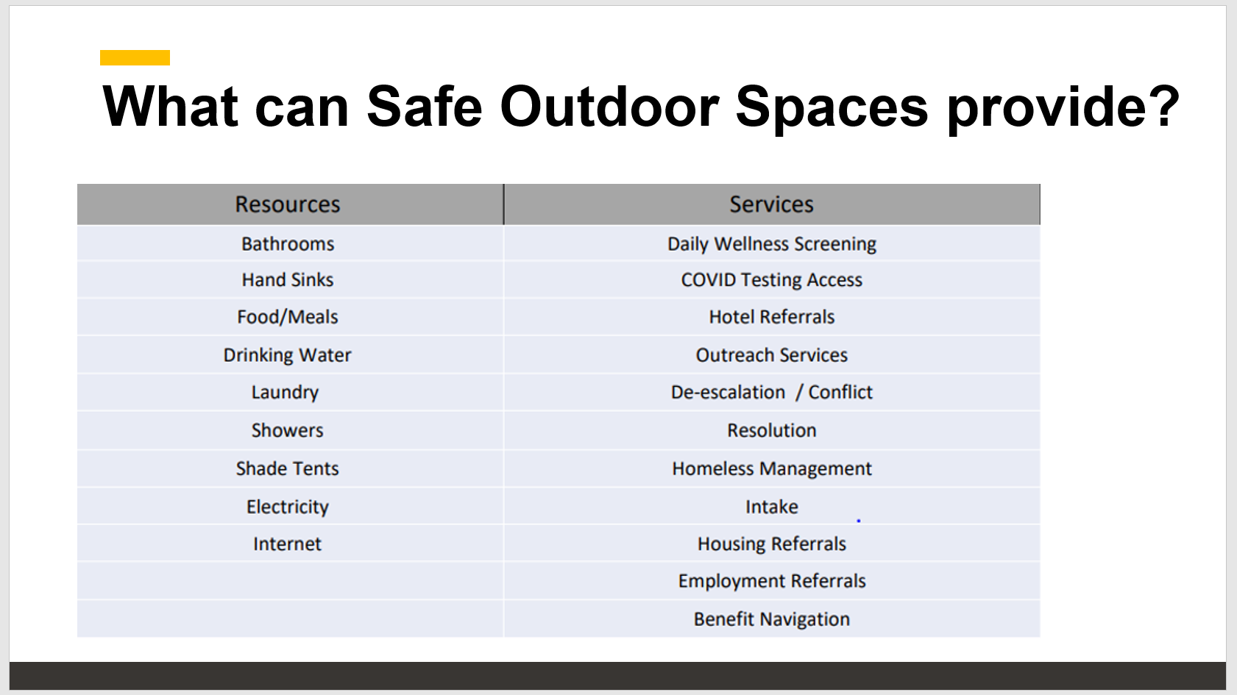

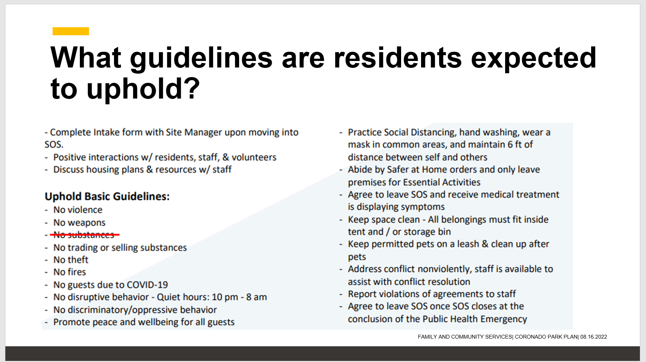

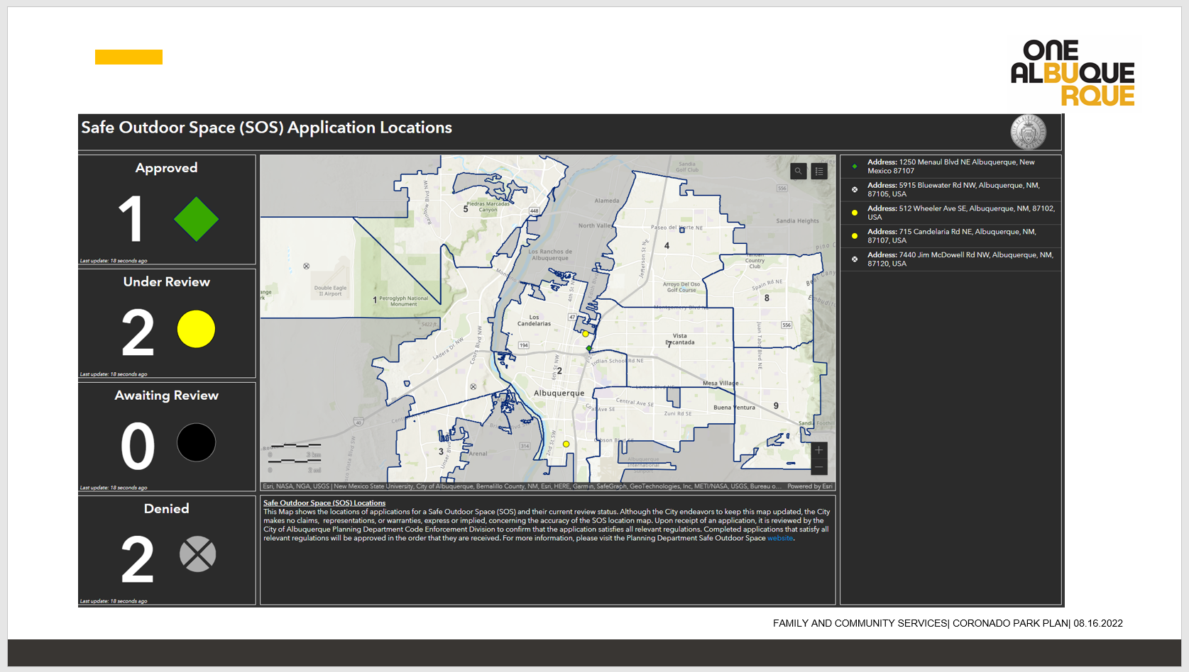
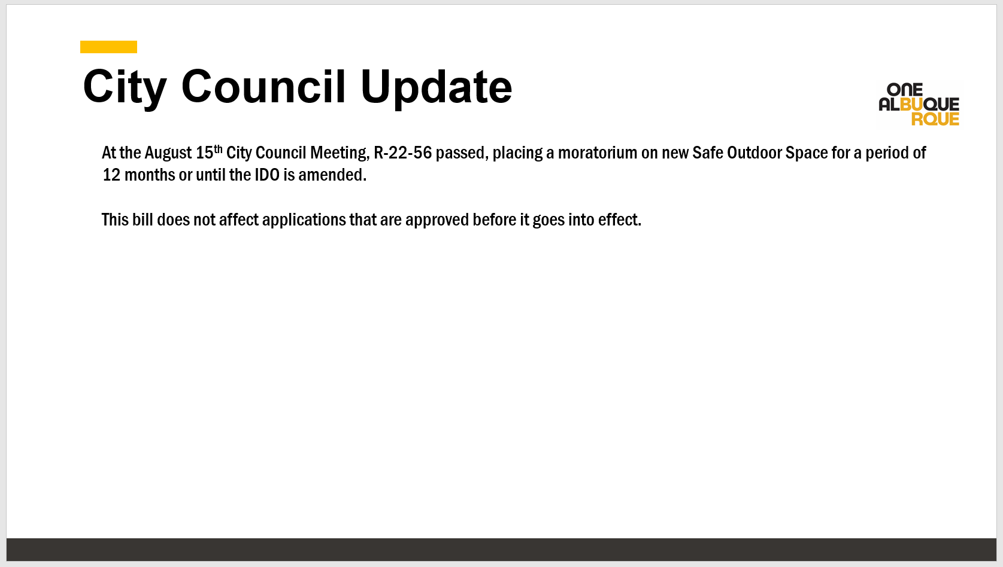

CIU, APD, and BSS Report and update, Commander Dietzel
Coty Maxwell
- A CIT 40-Hour is scheduled for next week, August 22nd through the 26th
- CIU Commander and some CIU Detectives will be going to the CIT International in Pittsburgh
- Detectives will be going to AOT Symposium
- CIU has been helping at Coronado Park with Outreach and Resources

Sub-Committees Report and update
Commander Dietzel
- Infoshare had a quick meeting
- We discussed SOP 2-59 Fire Protection Order Police
- Resource cards are in process and will be ready for printing soon and should be available in a month or so

David Ley
Q. The gun restraining order, is that the red flag law that New Mexico had in place but had not used?

Cmdr. Dietzel
A. Yes, one of the things with that law, is it is not very clear if you need that reporting party, or not. APD has not filed two of them. It’s important to understand that there is a difference between a gun restraining order and a formal restraining order. Usually, with any restraining order filed in a domestic violence situation, that person is restricted from having firearms.

DC Brown
This law has been in effect for over a year and throughout the state of New Mexico, I think it has only been used once prior. The CIU has used it twice over the last couple of months, successfully, I might add. The CIU has done a “killer” job getting this through, and they have paved the way in more ways than one, and one is in saving lives.

David Ley
- In our Training Sub-committee, we had a lovely dialog with ACS about trying to enhance their training materials for suicide prevention and suicide awareness.

MHRAC Final Discussion (5 minutes)
Commander Dietzel
A policy for review that was sent out is on the Officers Wellness Program; we can talk about that at the infoshare meeting.

David Ley
I looked that policy over a few minutes ago, it looks really good to me.

Gilbert
Q. Is there a need to have another hold the space at one of the sub-committees; whichever one would fit for Coronado Park updates, or do we just want to have it on the agenda for another update next month?

Max
I am wondering if there are internal meetings with the city and if someone from MHRAC could be there to be a voice where there is an appropriate time for that.

Next meeting: Tuesday, September 20, 2022

